Reports & Ticket Time Analysis Design Specification & Functional Documentation
Version: v1.0
Prepared By: Engineering Team
Status: Approved
Modules Covered:
- Ticket Time Analysis (Single Ticket View)
- Ticket Timeline Report (Multiple Tickets View)
Date: 16-01-2026

1. Purpose
This document defines the design, structure, and behaviour of the Ticket Time Analysis visualization, which is used in two contexts:
- Time Analysis Module – to analyse the lifecycle of a single ticket
- Reports Module – to analyse and compare the lifecycle of multiple tickets
Both contexts use the same timeline visualization, milestone logic, colour rules, and interaction behaviour.

2. Scope
This specification covers:
- Visualize ticket journey in a timeline / bar graph format
- Milestone-level time distribution
- Tooltip behaviour and user interaction rules
- Allow users to filter tickets by Start Date and End Date
- Provide high-level visibility into ticket progress and priority
No data modification or interaction beyond viewing is supported.

3. Module Relationship
Ticket Time Analysis is a reusable sub-module of the Reports module.
- The Time Analysis module displays the timeline for one ticket
- The Reports module displays the same timeline visualization for multiple tickets, stacked horizontally
There is no difference in visualization rules, calculations, or behaviour between the two.

4. Availability & Entry Points
4.1 Time Analysis (Single Ticket)
- Located in the Request tab → Time Analysis sub-menu.
- Shows timeline data for the selected ticket only
4.2 Reports (Multiple Tickets)
- Available under Reports in the top navigation bar
- Default landing view: Ticket Timeline Report
- Displays timelines for multiple tickets based on applied filters

5. Filters & Controls (Reports Module Only)
5.1 Date Range Filter
Field | Description
Start Date | Beginning of reporting period
End Date | End of reporting period
Rules:
- Both fields are mandatory
- End Date cannot be earlier than Start Date
- Tickets that are opened at any point within the selected date range are included in the report
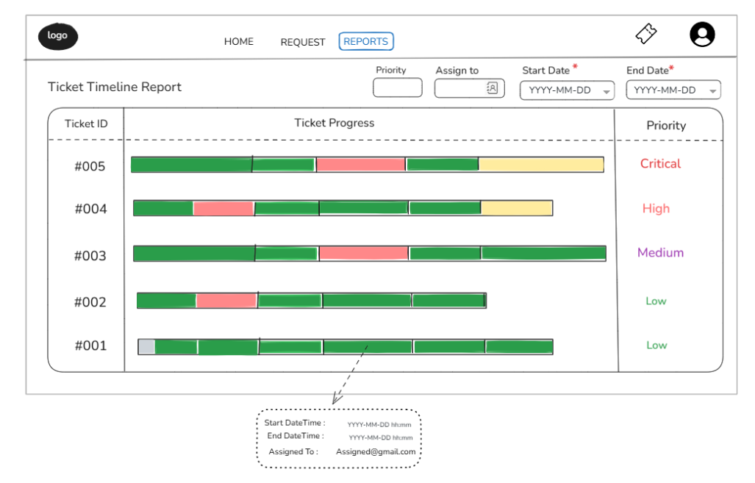

5.2 Assign To (Resolved By) Filter
Field |  | Description
Assign To | User selection dropdown
Functional Rules
- The filter represents the user who last handled or resolved the ticket
- If a ticket is resolved, the selected user is treated as Resolved By, and the ticket status is Closed
- If a ticket is still open, the filter reflects the current assignee
Multi-User Handling Rule
- If multiple users have worked on the same ticket:
  - Tickets are included the user was the final assignee

5.3 Priority Filter
Field | Description
Priority | Critical / High / Medium / Low
Functional Rules
- Users can filter tickets by one or more priority values
- Priority filter works in combination with Date Range and Assign To filters

6. Report Layout Structure
6.1 Report Table Sections
The report layout is divided into three primary columns:
- Ticket ID Column
- Ticket Progress (Timeline Bar Graph)
- Priority Column


7. Timeline Visualization Specification
(Applies to both Time Analysis and Reports)
7.1 Horizontal Timeline Bar
- Each ticket is represented by one horizontal timeline bar
- Timeline spans from:
  - Ticket creation date & time
  - To the latest milestone activity within the selected date range
- Timeline bars are:
  - Displayed in reverse chronological order (latest tickets on top) when multiple tickets are shown
Usage Context:
- Time Analysis → One timeline bar
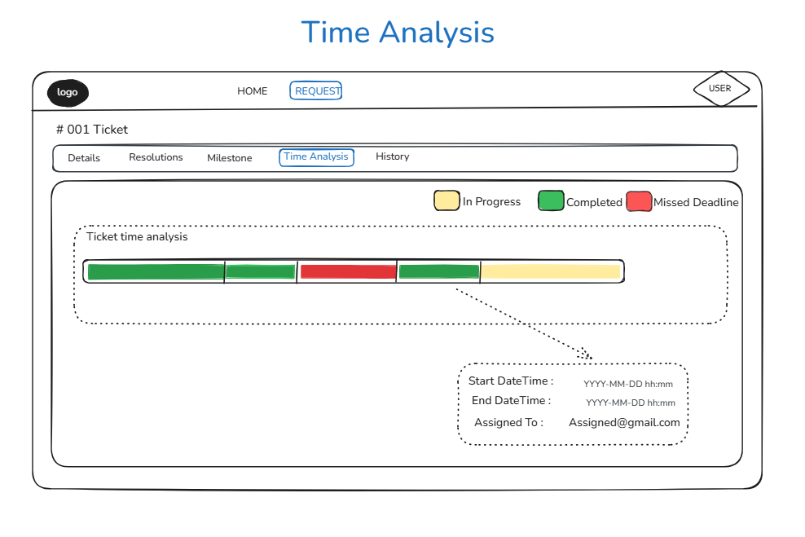
- Report → Multiple stacked timeline bars
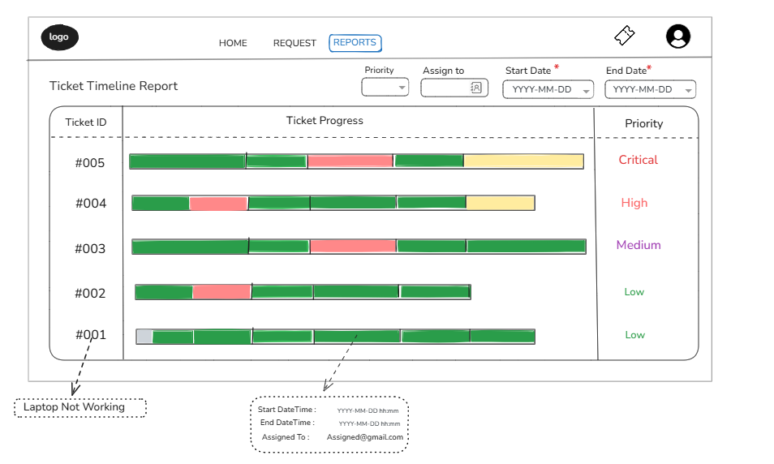

7.2 Milestone Components within Timeline
- Each timeline bar is divided into multiple milestone segments
- Each segment represents a distinct phase of the ticket lifecycle

7.3 Milestone Visualization Rules
- Each milestone is displayed as a coloured rectangular block
- Width is proportional to the actual time spent in that milestone
- Milestones are arranged chronologically from left to right
- Follow-up milestones appear as independent milestone segments

7.4 Status and Colour Encoding
Milestone blocks use colour to convey execution status:
COLOR | sTATUS
GrEEN | Completed within deadline
Yellow | In progress
Red | Deadline missed

- Colour evaluation is system-driven


8. Tooltip & Interaction Behaviour
(Applies to both modules)
8.1 Hover Interaction
- Hovering over any milestone segment displays a tooltip
- Tooltip behaviour is identical in single-ticket and report views
- Hovering on ticket Id, the title of the ticket will be displayed. (Only for Reports)

8.2 Tooltip Details
Field | Description
Start DateTime | Milestone start timestamp
End DateTime | Milestone end timestamp or current time
Assigned To | User responsible for the milestone

9. Audit, Data Integrity & Analytics
- Timeline data is derived from:
  - System audit logs
  - Ticket milestone history
- All data is:
  - System-generated
  - Immutable
  - Read-only
- Supports:
  - Audit review
  - Performance analysis

